***CkeckMarkx plugin installation on Eclipse***

The instructions below refer to local installation of the CxSAST Eclipse Plugin.

Download the CxSAST Eclipse plugin zip archive from this site <https://www.checkmarx.com/plugins/>.

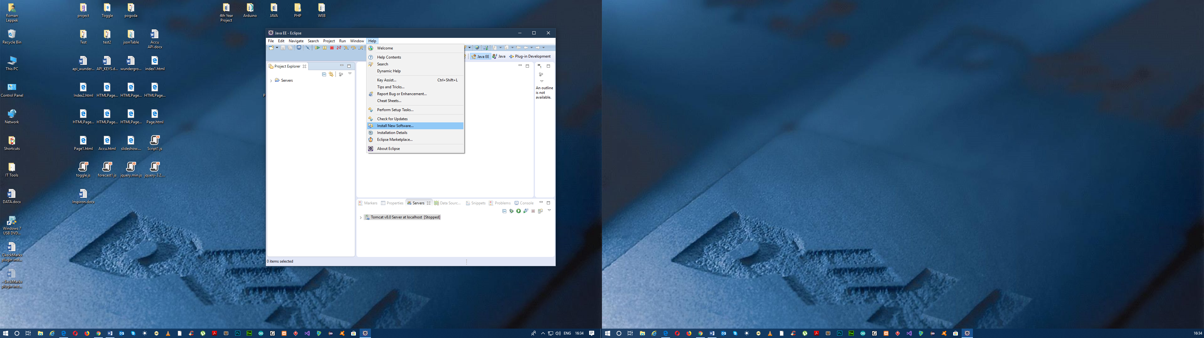

In Eclipse, go to the ***Help*** menu and select ***Install New Software***.

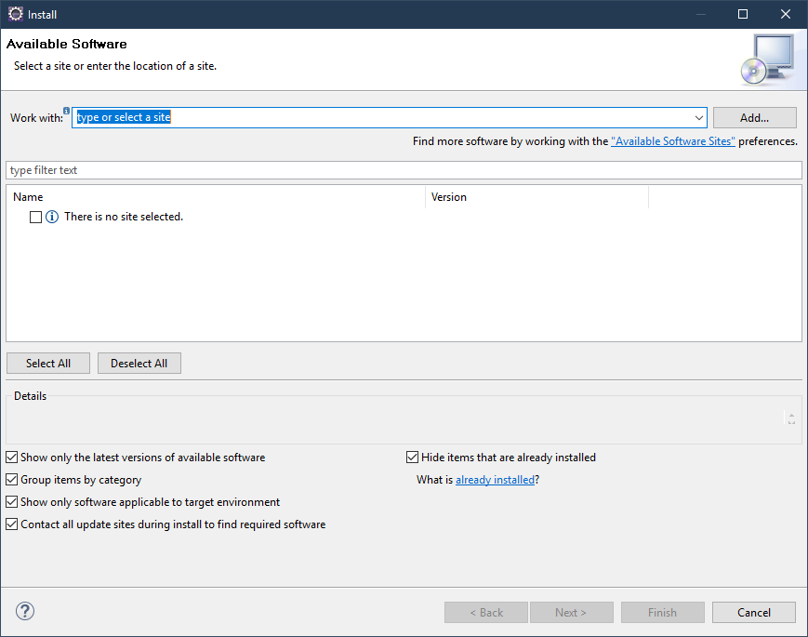

Click ***add.***

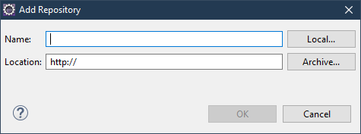

Add a name in the ***Name*** field - “CxViewerPlugin” and click ***Archive***.

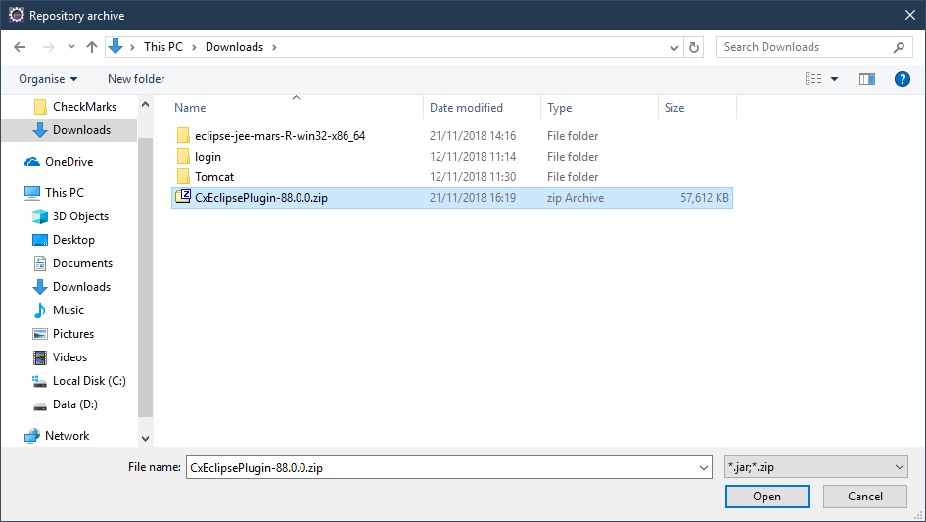

Browse to the CxEclipsePlugin zip file and click ***Open***.

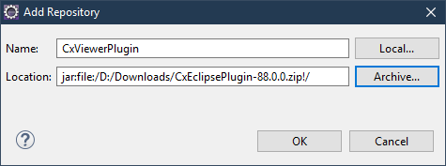

Click ***OK***.

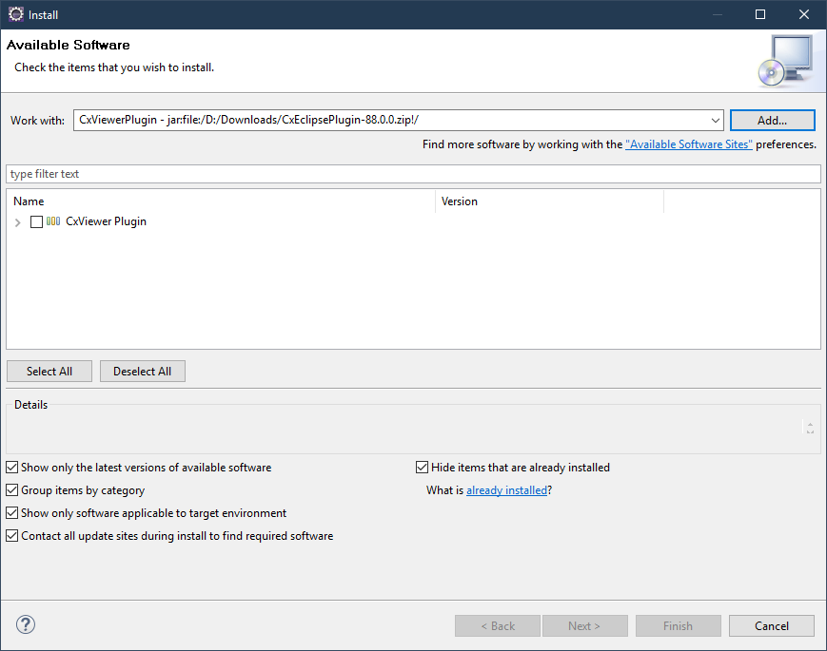

Check the box CxViewer plugin.

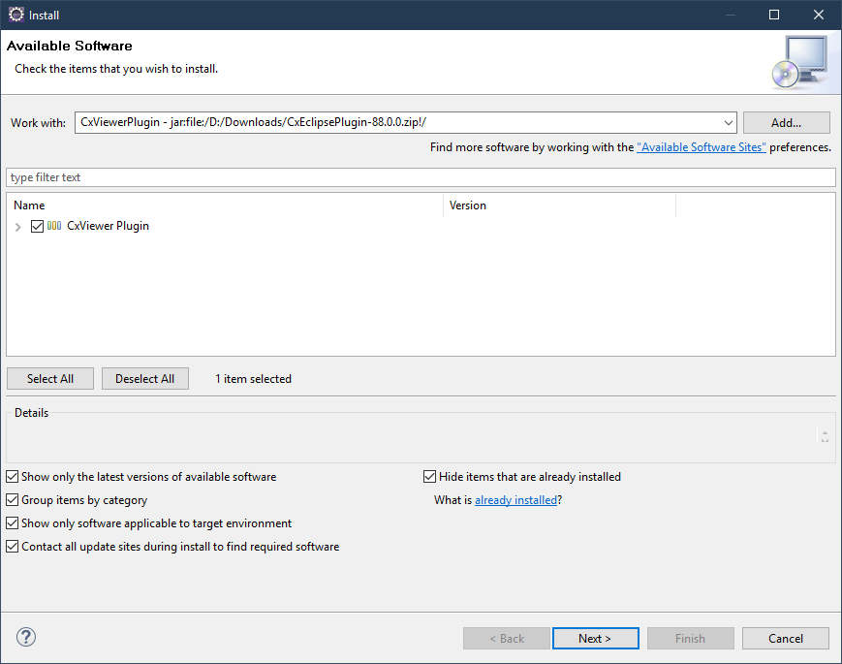

Click ***Next*** to install plugin.

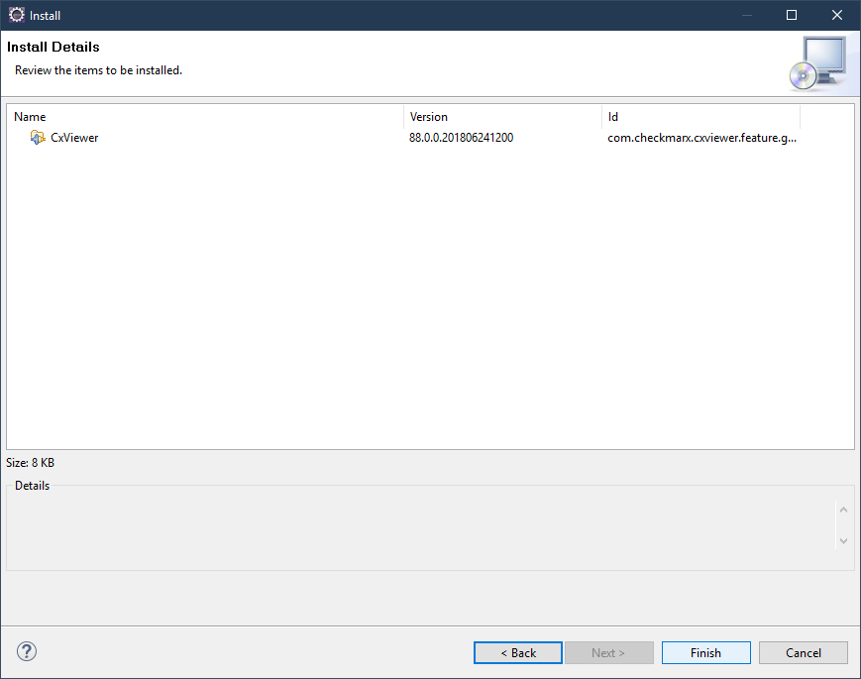

When the installation is finished, click ***Finish***.

Restart Eclipse.

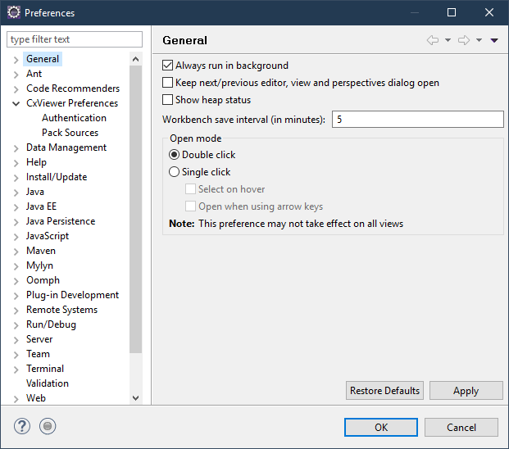

Go to the ***Window*** menu and select ***Preferences***.

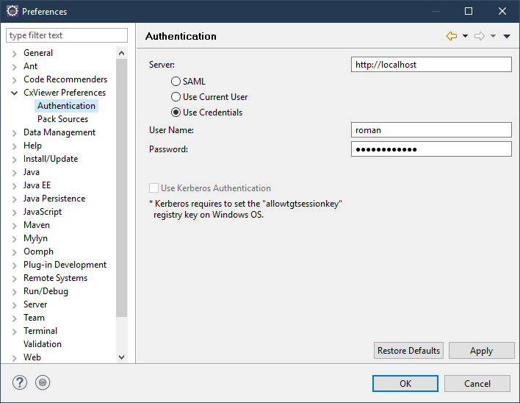

From ***CxViewer Preferences***, select ***Authentication***.

Add your CxSAST user credentials or select the "Use Current User" option if the SSO feature is active.

Click ***OK***.

***FIRST SCAN***

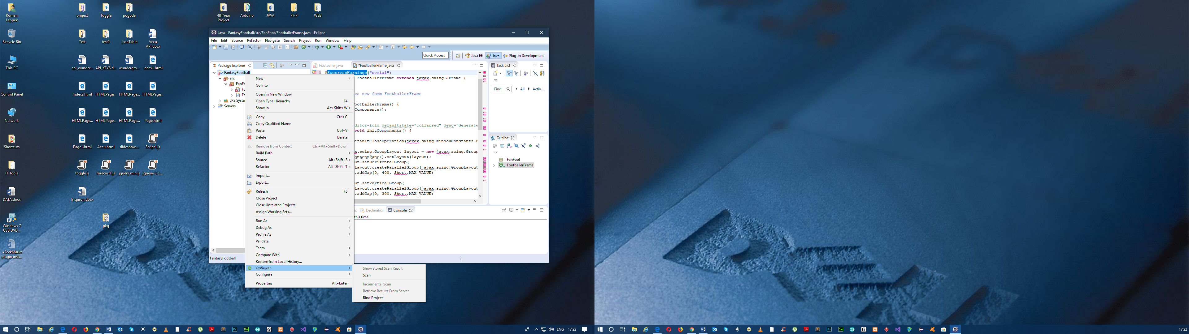

In Eclipse, right-click the project, folder, or file, and select ***CxViewer > Scan***.